Voluntary contribution to an Atlas of Fluid Inclusions

Contributor:
First name: Family name:
Email:
Address:

Insert photograph here (no annotation or scale bar):
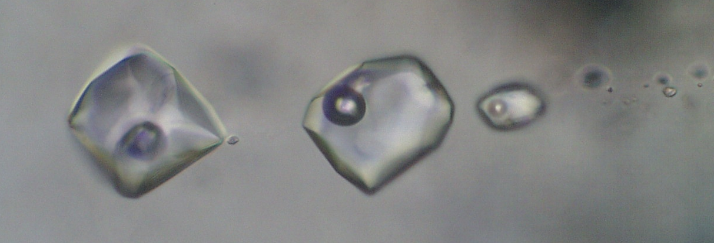

Insert a short description here (max. 100 words, including a statement of scale):
A trail of two-phase (liquid + vapor) pseudosecondary fluid inclusions observed in a quartz vein from the McArthur River uranium deposit (Athabasca basin, Canada) at room temperature. Study of the inclusions has revealed elevated uranium contents (tens to hundreds of ppm) and a halogen composition (chlorine, bromine) that indicates that the mineralizing fluids had an evaporated-seawater origin. Picture width: 100µm.

Please provide the original image file, at the best resolution possible, as an attachment to your contribution.

mail to: marie-camille.caumon@univ-lorraine.fr

